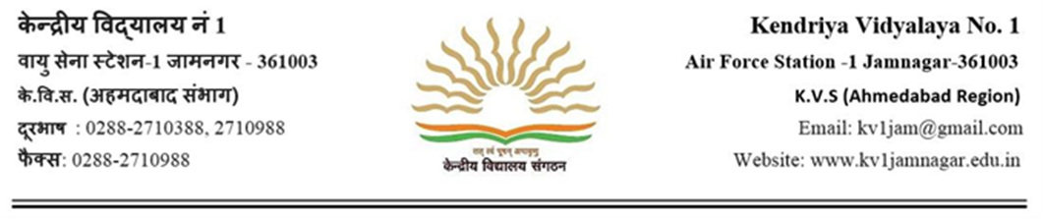संदर्भ: No. 1 Jam/2019-20/ दिनांक: 24/12/2020

INVITATION OF APPLICATIONS FROM REGISTERED PRIVATE MEDICAL PRACTIOTIONERS FOR APPOINTMENT AS AUTHORISED MEDICAL ATTENDANTS.
Applications are invited from registered private medical practitioners, practicing in the city of Jamnagar, for appointment as Authorised Medical Attendants (AMA) for the benefit of the employees of Kendriya Vidyalayas and their family members.
02. The private registered medical practitioner has to be qualified in the modern system of medicine holding a qualification recognised under the Indian Medical Council Act, 1956.
03. The private registered medical practitioner when appointed as authorised medical attendant should be required to follow, strictly, the rules and order issued under the CS (MA) Rules, 1944. They may particularly be required to note the salient points set out in the Appendix-XI of CS(MA) Rules, 1944 "Instructions to Doctors".
04. The AMA who are appointed/renewed as per this office circular No. 11/002/2018, dated 22.01.2019 and wish to continue as AMA has to apply in Annexure-A for he/she need not fill up any other form/Annexure.
04. Those private registered medical practitioner desires to be as AMA has to fill up the verification form, convey willingness in the prescribed format, affidavit in the prescribed format (Annexure-B to Annexure-D).
05. The instructions and all Annexures are available on the official website of this office viz. https://no1jamnagar.kvs.ac.in/ which may be downloaded.
06. Last date for receipt of applications in this office is 02.01.2021. The application received thereafter will not be entertained

Principal
K V No.1 Jamnagar,AFS-1

